Registers of Scotland

RoS Board

14 June 2022

RoS Data Enablement Strategy

Purpose

- This paper has been created to provide the Board with an overview of the new RoS Data Strategy as we transition into a data driven, data-centric organisation.

Recommendation

- Board is asked to:
  - Note the context of why a data strategy is important to RoS now.
  - Review & approve publication of external version of the strategy (Annex A)
  - Note the external, internal and team’s communications that will be used to share the strategy. (Annex B and C)
  - Note progress made from 2019 Gartner baseline and expected maturity in the coming 2 years (Annex D)

Background

- Through the Sasine and Land Register, RoS have been a data business, for over 405 years. Until now, that data has primarily been captured from deeds, transcribed to title sheets, and stored in human readable form with legal certainty requiring interpretation in all but the simplest scenarios.

- Looking towards 2024 and beyond, the organisation needs to deliver internal and external innovation though more structured approaches to its most important datasets. RoS needs to be reducing human interpretation, maximising automation, and delivering new bulk products, services, and analysis direct to customers, and policy bodies. We therefore need a strategy to drive from human interpreted documents to governed machine-readable data.

- This strategy should be seen as an enablement strategy. Structuring our data, building infrastructure, demonstrating governance, and aligning our teams to support the future data demands of RoS 2024+. Without these essential steps we will not be in a position to improve our data services across the organisation nor ensure we can extract maximum value (monetary and non-monetary) from these key assets.

Strategy Outline

- The strategy can be summarised in our vision to support these future needs.

“Empowering the business to unlock the full potential of its assets through machine-readable Data and Data driven services, maximising value to the citizens of Scotland, RoS and its customers”.
- The strategy is framed around our provisional five data principles. It is driven via three prioritised strategies (Core, Customer then Corporate) and delivered through service focused initiatives. All are aligned to driving business benefits and future capabilities through data. The diagram below shows the overall strategy. An additional diagram at Annex A.2 shows the strategy overlaid on RoS business flow.

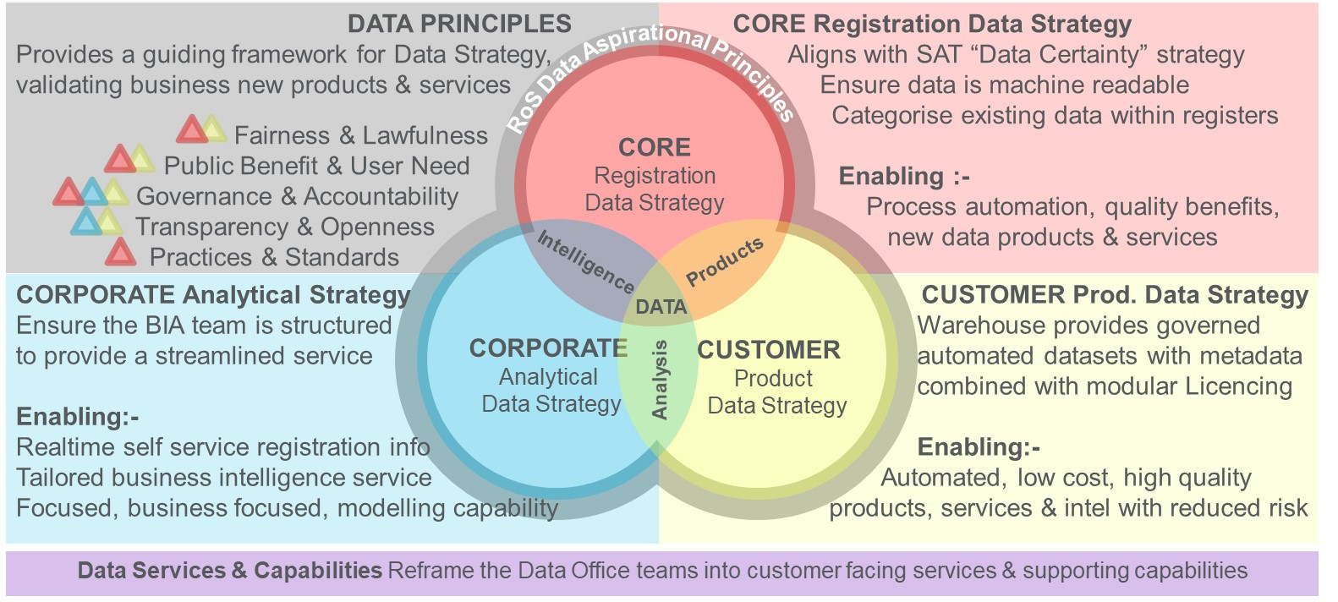

  - We will phase the implementation of our Data Principles, 1) sign-off and ensuring it is used as a checklist for all internal data related decision making. Once proved, 2) we will share externally to inform customers how data will be consumed, processed and published in RoS. The draft data principles are shown at Annex E.

  - The primary strategy will target our registration Core Data to ensure key LR information is machine readable, enabling legally certain interpretation. Implementation will be via two channels, SATs “Data Certainty Strategy” will deliver structured parent titles in TPd and structuring applications in RLP & Settle UI initiatives. The Data Office will look at data categorisation, data quality, data improvements, data debt and baselining. This will enable

  - increased registration process automation, better registration insights, quality benefits, new downstream data products & services. An example of data debt is shown at Annex F and the summary plan is shown at Annex C.1.

  - The secondary strategy will build on the improved core data and accelerate production of automated Customer Data though the warehouse, providing governed automated datasets, official national statistics, and other statistics with metadata combined with modular licencing. This will enable

  - automated, trusted, low-cost, high-quality products, services & intelligence with reduced risk. Create foundations for future Master Data Management capabilities. The summary plan is shown at Annex C.2.

  - In parallel to the core and customer strategies, we will accelerate unlocking business insights from Corporate Data, ensuring the BIA team is better serviced from the warehouse and aligned to provide timely business insights. This will enable

  - focused, real-time self-service registration info, enhanced business intelligence service for bespoke requests and maximised return on our modelling capability. The summary plan is shown at Annex C.3.

  - By focusing on Data Services & Capabilities across the Data Office, we will reframe team delivery through customer facing services and capabilities. This will enable

  - a customer focused and cost-effective approach to drive the strategies and initiatives forward based on our principles

- To articulate the strategy, we have material in Annex A (External focus), B (RoS wide) and C (Team level) which have been developed to provide effective visualisations for the communication of the strategy. The CDO will work with the Comms team to ensure messaging is effective across each area.

Due Diligence

- To ensure due diligence of the strategy, the underlying presentation and report has been discussed with the data teams, SAT, EMT, NXD and Gartner. Gartner was also used to baseline our maturity back in 2019. The progress made and next steps are tracked in Annex D

- The strategy methodology and overview have also been discussed in depth with Scottish Government bodies through data panels, 1-2-1s and Scottish Government data community of practices.

- RoS has two SG qualified statisticians who ensure our work in this area is fully compliant with the Code of Practice for Statistics.

Cost of Service

- The costs to deliver all areas of the strategy are difficult to quantify from SAT to Cloud hosting, but staff costs within the data office have been modelled with annual costs varying between £2.7 to 2.9 million over the coming 5 years. Additional costs will be subject to the appropriate internal governance through the EMT investment board. Existing return on investment for the data offices six areas are presented in Annex C.4

Conclusion

- The Board are invited to note this paper and provide advice and guidance regarding the recommendations detailed at paragraph 2.

Job Title Chief Data Officer
Directorate Data
Date June 2022

