Registers of Scotland

RoS Board

14th December 2021

Investors in People (IiP) overview

Purpose

- The purpose of this paper is to give Board an overview of the 2021 Investors in People (IiP) report to aid discussion about the report findings and the future direction with regards the IiP accreditation at RoS

Recommendation

- It is recommended that the Board note the findings of the paper and give their views on the future direction with regards to IiP. This could include:
  - focus on maintaining Gold accreditation
  - work towards attaining Platinum accreditation
  - review alternative options/accreditations to gain insight on colleague experience of RoS.

Background

- We gained Silver accreditation in June 2018. A KPI to attain Gold accreditation by 2021 was set and we went through a 3-year cycle of assessments which concluded with re-accreditation in August 2021. To gain Gold accreditation we had to pass 7 out of the 9 indicators at Advanced level

- For the re-accreditation we undertook the ‘We Invest in People’ online survey prior to the assessment. This was sent out to all colleagues and 54% of colleagues completed the survey. Appendix 1 gives an overview of findings from the survey.

- The IiP assessor then spoke to 98 colleagues from a range of roles and areas within the organisation and attended various sessions including the People and Workspace project board and People Managers’ session.

IiP Report overview

- The IiP report confirmed that we gained Gold accreditation by passing 7 out of the 9 indicators. Appendix 2 outlines where we have progressed since 2020 against the IiP indicators. The assessor outlined that there was a feeling of passing ‘a tipping point’ on our journey to transformation. More colleagues than ever are now embracing changes and have an appetite for what the future brings. There are still some colleagues who are not on board, but the majority now seem ‘on message’. In the report the IiP assessor highlighted many areas of positive change.

- Recommendations, see appendix 3, have been made by the assessor to continue our transformation and these recommendations would support a move towards platinum accreditation in the future. Appendix 4 outlines our current assessment with regards to the platinum standard.

- These recommendations/findings will be used alongside CSPS results, and themes from Big Picture, to highlight the RoS wide themes to concentrate on in the coming year to ensure appropriate and valuable actions are taken in line with the insight captured and aligned to business requirements. It should be noted that some of these recommendations, such as those outlined under Leadership, feature in the HROD critical path for this year and work is already underway.

- The results outlined in this paper have been discussed with PCS. There was a request for PCS officials to have a group meeting with the IiP assessor in future (similar to the EMT group session) so they can give a collective PCS view.

- There is an opportunity to review the ongoing relationship with IiP and the options include:

  - focus on maintaining Gold accreditation
  - work towards attaining Platinum accreditation
  - review alternative options/accreditations in place of IiP to gain insight on colleague experience of RoS.

- Maintaining Gold accreditation or striving for Platinum, which is only celebrated amongst 2% of organisations, would both require RoS to undertake a 3 year cycle of assessments. Striving to attain Platinum accreditation would require more focussed interventions and specific investment in the identified themes, with some aligned projects and work packages set up to generate the right progression to address gaps.

- We have noted IiP is an external means of assurance for both key risk 3 and key risk 7 on the key risk register as well as a detective control and means of assurance for two key risks delegated to directorate level. So, any alternatives would need to provide similar levels of data and analysis to enable us to effectively use the information to pro-actively manage these risks.

- If it was decided to leverage an alternative mechanism to capture and measure the effectiveness on people interventions and the people strategy implementation, we would lose Gold accreditation on 12 May 2022 (if no further annual activity was carried out) and would not be able to promote being an Investors in People accredited workplace.

- Board are invited to share insight and experience of working with alternative partners to IiP to measure colleague experience at RoS as a result of people interventions.

Conclusion

- Board is asked to review the paper and discuss and respond to the points outlined in the recommendation.

Colleague Experience Manager
Corporate Directorate
29th November 2021

Appendix 1 – We Invest in our People survey highlights

Highlights from the We Invest in our People survey

Indicator that achieved the best results | Indicator 4: Managing performance with 82.5% aggregated agreement across all statements.
The indicator that received the lowest level of agreement responses | Indicator 5: Recognising and rewarding high performance with 58.9% agreement aggregated across all statements.
The best performing statement | Indicator 3: Empowering and involving people had a 93.5% positive response regarding the statement ‘I understand how my role contributes to the organisation’
The statement that received the highest number of ‘strongly agree’ ratings | Indicator 6: Structuring work - the statement ‘My work is interesting’ received ‘strongly agree’ from 46.9% of respondents
The statement that received the greatest negative response | Indicator 7: Building capability- the statement ‘People are selected for roles based on their skills and abilities’ received ‘disagree’ / strongly disagree’ from 43.6% of respondents

Appendix 2: Heatmap 2020 v 2021

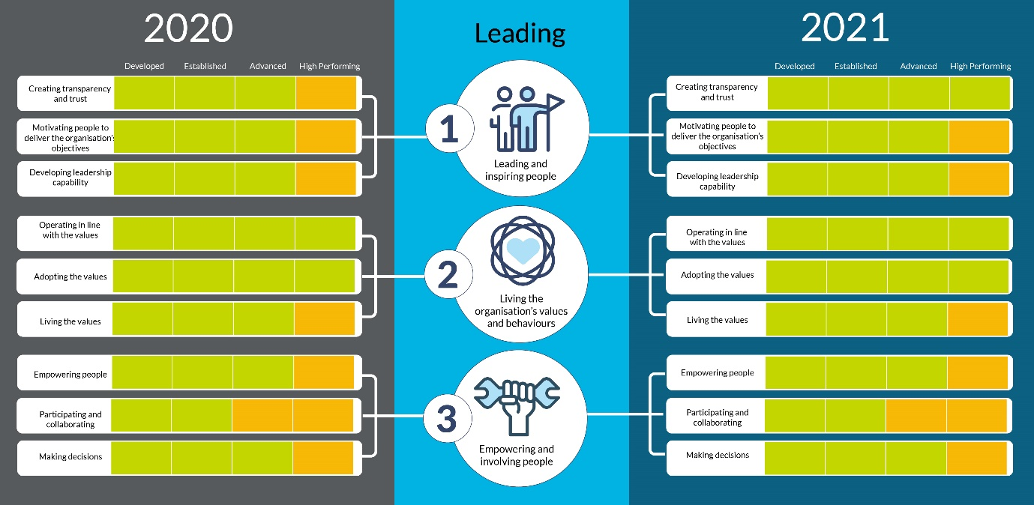

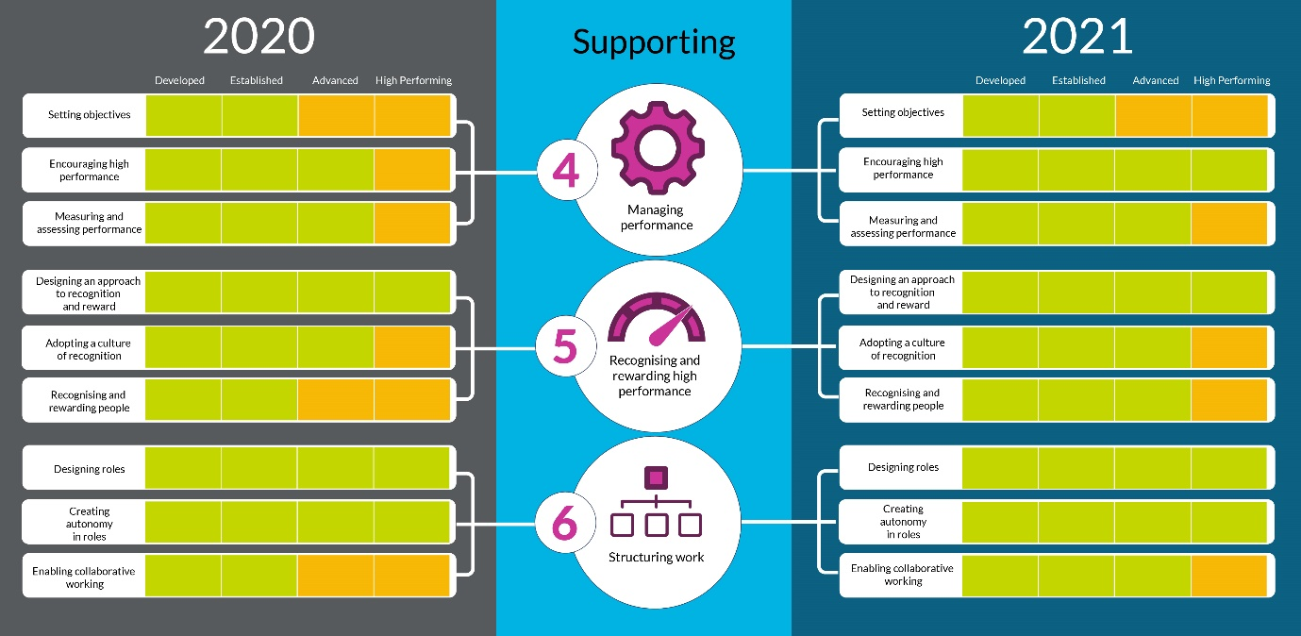
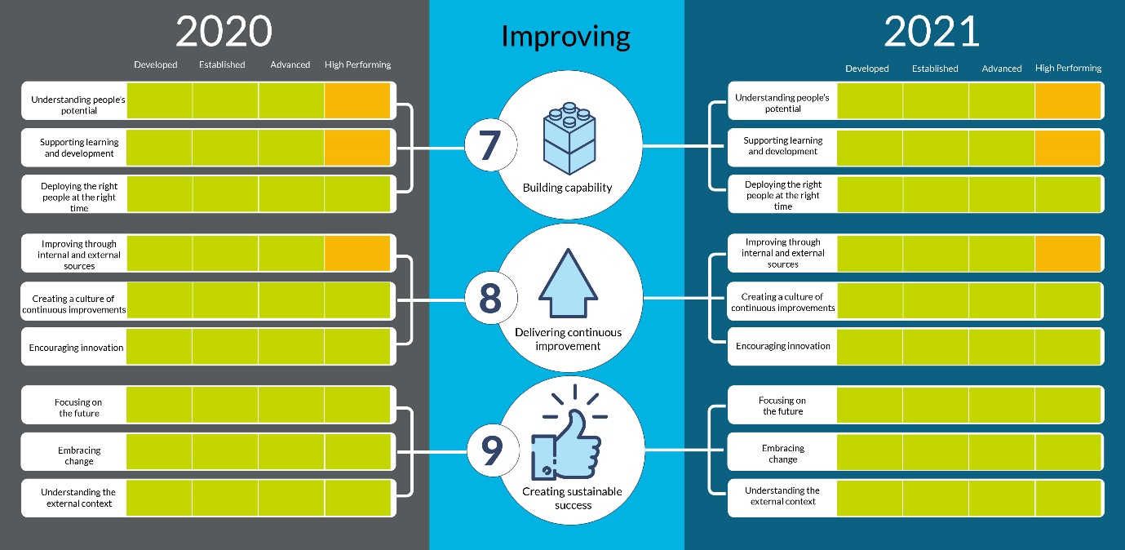

Appendix 3 – IiP recommendations

Recommendation theme | Recommended actions
Leadership | - redefine what is expected of leaders  - support them to move from control to facilitative leadership approach,  - embed psychological safety  - develop leadership behaviours through emotional intelligence and a growth mindset
Colleague Voice | - share more ‘you said…we did’ communications to help colleagues better connect the link between their feedback and meaningful organisational action.
Performance reviews | - review the performance management approach and transition to a ‘My Contribution’ approach where feedback is more regular, objectives are more meaningful, and progress is more transparent.
Recognition | - increase peer to peer recognition  - congratulating people when things are done well to motivate and engage colleagues.

Appendix 4: Platinum level heatmap

Indicators | Themes | High performing
1. Leading and inspiring  people | Creating transparency and trust
Motivating people to deliver the organisation’s
objectives
 | Developing leadership capability
2. Living the  organisation’s values  and behaviours | Operating in line with the values
 | Adopting the values
 | Living the values
3. Empowering and  involving people | Empowering people
 | Participating and collaborating | *
 | Making decisions
4. Managing  performance | Setting objectives | *
 | Encouraging high performance
 | Measuring and assessing performance
5. Recognising and  rewarding high  performance | Designing an approach to recognition and reward
 | Adopting a culture of recognition
 | Recognising and rewarding people
6. Structuring work | Designing roles
 | Creating autonomy in roles
 | Enabling collaborative working
7. Building capability | Understanding people’s potential
 | Supporting learning and development
 | Deploying the right people at the right time
8. Delivering  continuous  improvement | Improving through internal and external sources
 | Creating a culture of continuous improvements
 | Encouraging innovation
9. Creating sustainable  success | Focusing on the future
 | Embracing change
 | Understanding the external context

* Would require to also meet the Advanced level

