Registers of Scotland

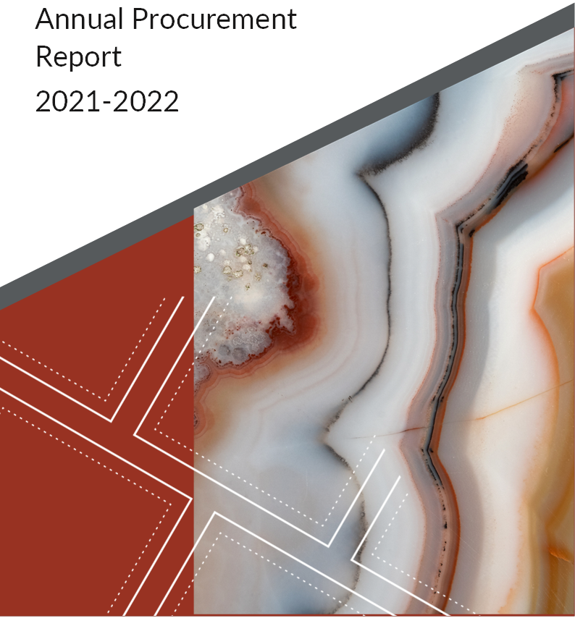

CONTENTS

Contents

Introduction 3
Procurement Journey 4
RoS Regulated Procurement during 21/22 4
Summary of All RoS Contracted Procurements 5
RoS Procurement in Numbers 5
Responsible and Sustainable Procurement 7
Learning and Team Development 11
Procurement Pipeline - Projects and New Procurements 11

Annual Procurement Report
2021-2022

Introduction

Registers of Scotland (RoS) is a public sector contracting authority, subject to the Procurement Reform (Scotland) Act 2014. We are required to produce an annual report on our regulated procurement activities.
RoS champions the Scottish Procurement Model by embedding sustainable procurement. Sustainable procurement is “a process whereby organisations meet their needs for goods, services, works and utilities in a way that achieves value for money on a whole life basis and generates benefits not only to the organisation but also to society, the economy and the environment.”
Our key procurement principles incorporate fairness, openness, transparency, mutual recognition, non-discrimination, and proportionality.
RoS is pleased to publish our Annual Procurement Report which meets the requirements of Scottish Ministers (Scottish Procurement Policy Note 4/2021) and is aligned to the RoS Corporate Procurement Strategy.
Our Strategy includes the 2021 RoS Procurement Vision and Mission Statement and meets the requirements of Scottish Ministers (SPPN 11/2016).
This report contains detail of our regulated procurements and key highlights from the 2021/22 fiscal year.
RoS continues to adapt and respond to changes to the external environment we operate in. In 2021/22, this has included our continued response to the COVID-19 crisis and Climate Emergency Action Plan.

Procurement Journey

To ensure consistency of approach in the Scottish public sector, we are asked to adhere to the Scottish Government’s Procurement Journey, as shown in Figure 1.
At RoS, we ensure compliance with this model throughout our work, there is clear alignment of our practices to the stages of the Procurement Journey.
Our central Procurement team collaborates with internal customers to develop new contracts.

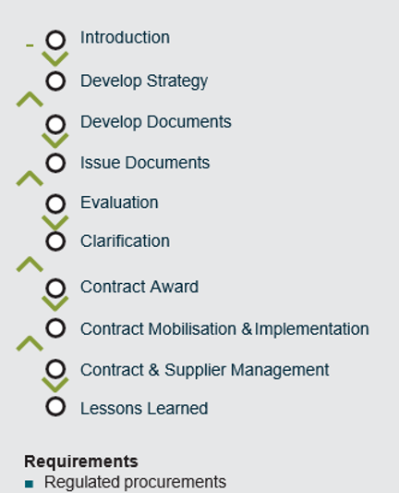

Figure 1 – Scottish Government’s Procurement Journey

RoS Regulated Procurement during 21/22

The procurement team collaborate closely with internal customers to develop new requirements and the renewal of existing contracts. During the 2021/22 period RoS completed 276 regulated procurement exercises.
RoS has a commitment to use Scottish Government and Crown Commercial Services Frameworks where possible. Below is a summary of this procurement activity.
- 285 Quick Quotes completed (On Framework)
- 5 World Trade Organisation/Global Procurement Agreement Procurement exercises
- 276 Regulated Exercises (Non-OJEU)

Summary of All RoS Contracted Procurements
See appendix A

RoS Procurement in Numbers
Top 10 Areas of Spend (%) 21/22
Security - Services Hardware
1.3
(ICT Stock)
1.4
Soft Services
1.4
Technical Services
2.8
Fabric & Other Project Costs
3.8
Professional Services
5.4
Software Inventory
5.8
Hardware (ICT)
6.6
Software
7.5
Departmental Training
1.1
0
1
2
3
4
5
6
7
8
£30,528,159  Total Spend |  |  |  | £12,214,430  SME spend
256  Suppliers |  | 138  SME Suppliers |  |  |  | 38%  SME Spend
£8,000  Supported Business Spend |  |  | £1,990,275  Annual Cash Saving |  | 6.1%  Annual Saving
1.1%  GPC Spend | 3  Non-Competitive Actions

Responsible and Sustainable Procurement

The Procurement Reform (Scotland) Act 2014 includes a sustainable procurement duty on public sector bodies which requires them to conduct their procurement in a way that will secure economic, social, and environmental wellbeing and a requirement that public bodies consider the use of community benefits in major contracts.

RoS continues to promote the use of community benefits within procurement exercises where relevant and proportionate to the contract.

All contracts appointed in this period support the living wage and are striving to deliver further community benefits.

Prompt payment

Prompt payment is a priority when seeking to act in a responsible and sustainable manner. We are committed to paying suppliers and understand the importance of prompt payment to ensure that suppliers do not have cash flow difficulties. Our on-time payment performance is 93.77% payments made in fewer than 10 days and 99.37% within 30 days.

Fair Work practices

RoS has adopted Fair Work First principles as an employer, through commitment to the delivery of high-quality public services, and recognises that this is critically dependent on a workforce that is well- motivated, well led, has appropriate opportunities for training and skills development and is engaged in decision making at all levels across the organisation.
These factors are also important for workforce recruitment and retention, and continuity of service.
To ensure the highest standards of service quality in the contracts we procure, we expect suppliers to evidence a positive approach to fair work practices as part of a fair and equitable employment and reward package for all employees (whether permanent or contingent workers) involved in the delivery of any RoS Contract.
To ensure the highest standards of service quality in the contracts we procure, we expect suppliers to evidence a positive approach to fair work practices as part of a fair and equitable employment and reward package for all employees (whether permanent, temporary or agency) involved in the delivery of any RoS contract.
Where proportionate and relevant we evaluate tender responses on the following Fair Work First criteria: -
- A fair pay and equal pay policy that includes a commitment to supporting the real Living Wage, including, for example, being a Living Wage Accredited Employer
- Investment in workforce development including a strong commitment to Modern Apprenticeships
- No inappropriate use of zero hours contracts
- Flexible working (flexitime and career breaks) and support for family friendly working and wider work life balance
- Appropriate channels for effective voice and employee engagement, including trade union recognition
- Take action to tackle the gender pay gap and create a more diverse and inclusive workplace, which reflects the population of Scotland in terms of age, gender, race, and disability.
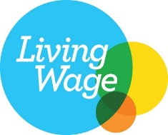
Each of the above, where applicable, will be monitored throughout the lifetime of the contract as part of our contract management process.

Modern Slavery

In 2022/23 RoS will publish our Modern Slavery Statement. This details the measures that RoS are taking to ensure that no modern slavery or human trafficking is occurring in our organisation or our supply chains.
To raise colleague awareness of the risk of Modern Slavery further, a Best Practice Guidance Note will be published.

Equality, diversity, and inclusion

The Public Sector Equality Duty requires public authorities, in the exercise of its functions, to have due regard to the need to:
- Eliminate unlawful discrimination, harassment and victimisation and other conduct that is prohibited by the Equality Act 2010
- Advance equality of opportunity between people who share a relevant protected characteristic and those who do not
- Foster good relations between people who share a protected characteristic and those who do not.

Community Benefits

RoS consider inclusion of Community Benefits in line with S18(2) of The Procurement Reform (Scotland) Act 2014 for all procurement processes for relevant contract at or above £4 million in value. As an organisation we have decided to go further and consider Community Benefits, for all procurement at or greater than £1 million in value.

Supported Businesses

RoS uses the Supported Businesses Framework for Furniture and Signage and IT Waste Disposal, as and when we have a procurement requirement. We engage with supported businesses and will continue to seek future opportunities to use, as relevant as appropriate and consider as per of our contract strategy development.

SMEs

We are pleased to report that during this period we have worked with a wide range of suppliers. During 2021/22, 38% of RoS’s total spend was from working with 138 SMEs with a spend profile of £12,214,430.

RoS continues to be a member of the Supplier Development Programme (SDP).

The SDP was established in 2008, and is a partnership of Local Authorities, Scottish Government and other public bodies working together to provide free support to businesses in all aspects of tendering. The SDP assists businesses to become tender ready for public procurement and improves all-round efficiency, sustainability, and market potential.

More information can be found at www.sdpscotland.co.uk
.

Climate Change

In September 2021 RoS published a 5-year Sustainability & Climate Change Strategy which sets out our vision on how we aim to reach net zero by 2045. We will aim to reduce our carbon footprint by 11% annually and the areas which we will focus on to achieve this include:
- Energy use and water management
- Waste and circular economy
- Digital innovations
- Sustainable travel and staff commuting
- Sustainable procurement
- Biodiversity
- Green recovery: hybrid working

Through our Procurement activity we will:
- Drive environmental performance reporting
- Improve efficient use of resources.
- Continued integration of sustainability criteria into contracting and incorporating monitoring where possible in line with relevant specifications.

Savings

Using the Scottish Government’s “Procurement Benefits Reporting Guidance” methodology, RoS procurement achieved £1.96m of cash savings for the period, a 6.5% saving on the annual expenditure. This has been achieved by identification of available frameworks and further competitions.

Learning and Team Development

RoS use the Scottish Governments Public Sector Procurement Competency Framework to aid professional development within the Procurement Team. This is based on the four pillars of Global Occupational Standards below (figure 2):
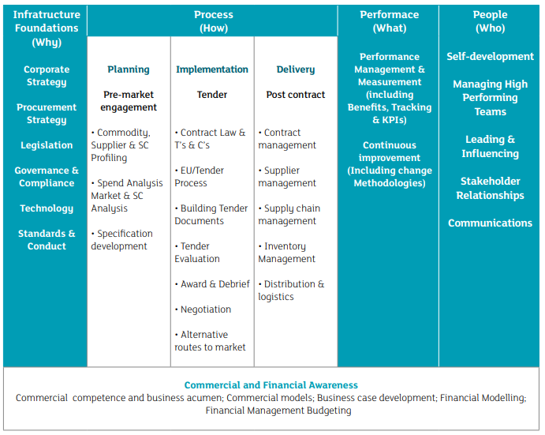
Figure 2 -
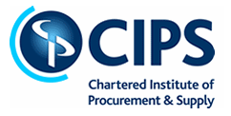
Professional development for the team also continues through the Chartered Institute for Purchase and Supply.
The team also undertook internal and external training to further their knowledge and expertise, The courses included: - CIPS, Circular Procurement Training, Introduction to Public Procurement, Cyber Security Training

Procurement Pipeline - Projects and New Procurements
Below is a list of potential upcoming opportunities (subject to Business Case sign off)
See appendix B

