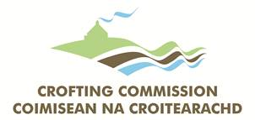
CROFTING REGISTER FEE DETAILS
Registration fees are collected from you, as the applicant, by the Crofting Commission on behalf of Registers of Scotland and once collected, are paid directly by the Crofting Commission to Registers of Scotland on your behalf.
Fee payable  (a discount may be available for group applications – see below) | £90.00
We can accept payment by | Cheque
Please make cheques payable to | The Crofting Commission

Please complete the details below.
I enclose my cheque payable to  “The Crofting Commission” for | £
My croft name is

If in doubt please contact the Crofting Commission for advice.

