Registers of Scotland

RoS Board

13 September 2022

Key risk register (KRR)

Purpose

- The purpose of this paper is to provide the board with an update on the KRR 2022-27 following EMT and Audit & Risk Committee (ARC) reviews, continuous Key Risk Owner (KRO) reviews and the annual risk workshop.
- The paper supports the board in fulfilling its role to provide strategic advice to the Keeper and for its focus on setting a framework of prudent and effective controls that enables risk to be assessed and managed.

Recommendation

- RoS Board is requested to review the KRR summary at Annex 1 and advise the Keeper on the update.
Background

- RoS KRR contains the key risk scenarios that may affect delivery of our corporate plan objectives and the risk response strategies for these threats and opportunities. The KRR is a ‘live’ document which is reviewed and updated at least monthly by KROs and submitted to EMT for approval as part of their monthly corporate governance review process. The KRR is also submitted to RoS Board and ARC meetings for noting and/or advice as a summary report or as the RoS Assurance Framework report.

Key risk register (KRR)

- The paper adopts a ‘reporting by exception’ approach comprising 3 elements:
Reporting element | Frequency of reporting | Board input / ‘Ask of the Board’
1. RoS Key Risk profile | Every Board meeting | Advice on whether strategic risk exposure continues to be captured by the KRR
2. New/developing risks | As relevant | Advice on how risks have been assessed in terms of ‘causes - scenario - impacts’ and the risk response (i.e. controls)
3. Risks trending away from target risk score / controls not delivering anticipated risk response | As relevant | Advice on how risks have been assessed in terms of ‘causes - scenario – impacts’ and the risk response (i.e. controls)

KRR reporting element 1 - RoS Key Risk Profile

- A summary of the KRR as at the date of this paper is at Annex 1. The ‘Live’ KRR will be available to RoS Board at its September 2022 meeting. The KRR incorporates outputs from the risk workshop in May, including agreed updates to risk scenarios (causes, scenario descriptions and impacts).
KRR reporting element 2 – New/developing risks

- No new/developing risks have been identified since the last update to the Board.

KRR reporting element 3 - Risks trending away from target risk score / controls not delivering anticipated risk response

- The likelihood assessment for Key Risk 1 Financial Health (There is a threat that RoS is unable to achieve and maintain a financial break-even position every year) was reviewed following the risk workshop, increasing from ‘Low’ to ‘Medium’. The overall risk score increases from 8 to 12. Outputs from the workshop and awareness of the level of uncertainty in the economy, the property market and other areas prompted the re-assessment. The potential of this increased uncertainty to affect achievement of a break-even position is reflected in the increased likelihood score.

- In response to this re-assessment the Finance team are considering a range of options for reducing expenditure should the need arise because achieving a break-even position looks in doubt. These options are presented elsewhere in the September Board agenda.

- Existing risk responses for all other key risks continue to deliver the expected risk reduction effects, with no material exceptions to report in Q1. The ongoing introduction of new controls and/or enhancements to existing controls is continuing as planned in each risk’s ‘route to target’.

- The criticality and interdependence of our responses to Key Risks 3 (Operational Capacity) and 7 (People & Change) were noted at the risk workshop and in the June Board meeting. EMT continue to focus on both risks, with expanded EMT attendance at monthly risk reviews (in addition to Key Risk Owners). Risk reviews since the June Board meeting have considered whether control interventions are sufficient to fully address each risk, the timing and sequence of interventions, and means of assurance to demonstrate the effectiveness of our interventions. EMT concluded that each risk’s ‘route to target’ remains realistic and proportionate, with progress continuing to be monitored monthly.

- ARC reviewed and noted updates to the KRR Assurance Framework 2022-27 at their August 2022 meeting.
- The KRR and Assurance Framework 2022-2027 are now ‘live’ for ARC, RoS Board and EMT ongoing review and oversight.

Conclusion

- RoS Board to review the KRR update and Annex 1, and consider the background, topic matter and recommendations in this paper for advice to the Keeper and EMT.
Head of Enterprise Risk Management
Corporate
22 August 2022

Annex 1a Key Risk Register Infographic
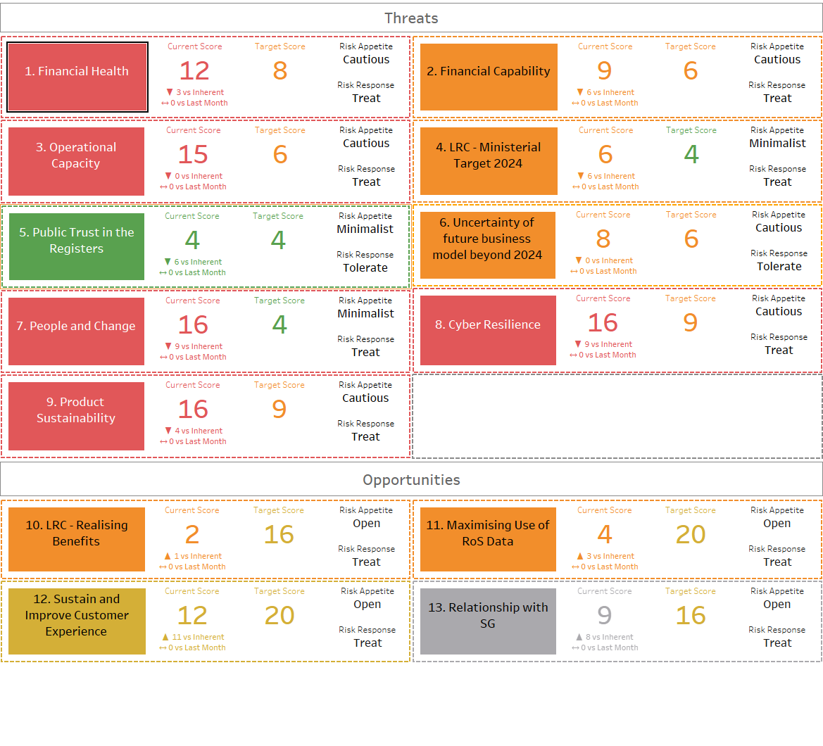

Annex 1b Key Risk Register Matrix
