Registers of Scotland

RoS Board

13 December 2022

Key risk register (KRR) & Annual Risk Management Policy review

Purpose

- The purpose of this paper is to provide the board with an update on the KRR 2022-27 following EMT and Audit & Risk Committee (ARC) reviews, continuous Key Risk Owner (KRO) reviews.
- The paper supports the board in fulfilling its role to provide strategic advice to the Keeper and for its focus on setting a framework of prudent and effective controls that enables risk to be assessed and managed.

Recommendation

- RoS Board is requested to review the KRR summary at Annex 1 and advise the Keeper on the update.
- RoS Board is requested to review the draft Risk Management policy 2022 at Annex 2 and advise the Keeper and EMT.
Background

- RoS KRR contains the key risk scenarios that may affect delivery of our corporate plan objectives and the risk response strategies for these threats and opportunities. The KRR is a ‘live’ document which is reviewed and updated at least monthly by KROs and submitted to EMT for approval as part of their monthly corporate governance review process. The KRR is also submitted to RoS Board and ARC meetings for noting and/or advice as a summary report or as the RoS Assurance Framework report.

- The Risk Management policy is owned by EMT and is reviewed annually by EMT, PCS Trade Union, ARC and RoS Board.

Key risk register (KRR)

- The paper adopts a ‘reporting by exception’ approach comprising 3 elements:
Reporting element | Frequency of reporting | Board input / ‘Ask of the Board’
1. RoS Key Risk profile | Every Board meeting | Advice on whether strategic risk exposure continues to be captured by the KRR
2. New/developing risks | As relevant | Advice on how risks have been assessed in terms of ‘causes - scenario - impacts’ and the risk response (i.e. controls)
3. Risks trending away from target risk score / controls not delivering anticipated risk response | As relevant | Advice on how risks have been assessed in terms of ‘causes - scenario – impacts’ and the risk response (i.e. controls)

KRR reporting element 1 - RoS Key Risk Profile

- KROs have reviewed their key risks and updated where appropriate risk descriptions, appetite, proximity, scoring, controls and assurance opinions. A summary of the KRR as at the date of this paper is at Annex 1. The ‘Live’ KRR will be available to RoS Board at its December 2022 meeting.
- The annual EMT, ARC and Board risk workshop will take place on 17 January 2023. ERM will use pre-workshop survey results to inform a workshop briefing pack and agenda for the session, focussing on:
  - new/developing risks not covered by existing key or directorate risks
  - priority key risks as determined by the survey results
KRR reporting element 2 – New/developing risks

- Key Risk 1 Financial Health: scenario changed from:

"There is a threat that RoS is unable to achieve and maintain a financial break-even position every year" to;

"There is a threat that RoS is asked to contribute to the SG budget this year and in future years, rather than financially break-even."

This expands the Financial Health key risk to include: (i) management of our relationship with SG to ensure we have early visibility of any budget contribution expectations and (ii) management of our finances to ensure corporate plan delivery and a financial break-even year end position as a minimum. The existing control set responds to both elements and the route to target for FY 22-23 remains on track. Future reviews of this risk will look ahead to an assessment for FY 23-24, with the expectation this threat may increase.

- Key Risk 10 LRC - Realising Benefits (aligned to strategic objectives 1 and 2) - route to target updated to include proposed development of an Unlocking Sasines data surfacing mechanism and to simplify user groups into 'Internal', 'External/Business' and 'Public'. This results in an earlier than anticipated increase in likelihood in Q4 23-24 (from Q3 24-25 in the previous route to target) as internal and external/business users are able to access LRC data:

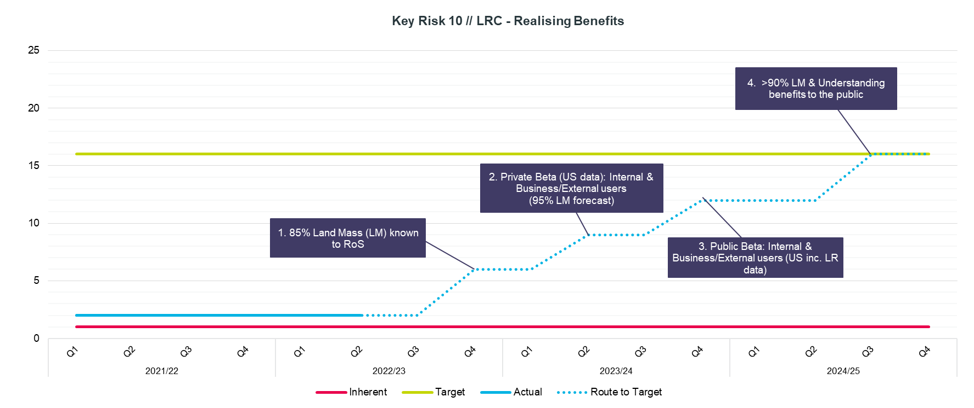

KRR reporting element 3 - Risks trending away from target risk score / controls not delivering anticipated risk response

- Key Risk 6 Uncertainty of future business model beyond 2024 (aligned to strategic objectives 4 and 6): scenario changed from:

"There is a threat that insufficient strategic thinking will inhibit our ability to formulate a longer term vision and strategic direction for RoS beyond 2024" to;

"There is a threat that insufficient strategic thinking will inhibit our ability to realise our long term vision and respond strategically beyond 2024".

Route to target updated with additional elements, achievement of target risk score now anticipated in Q4 22-23 (from Q3 in previous scenario):

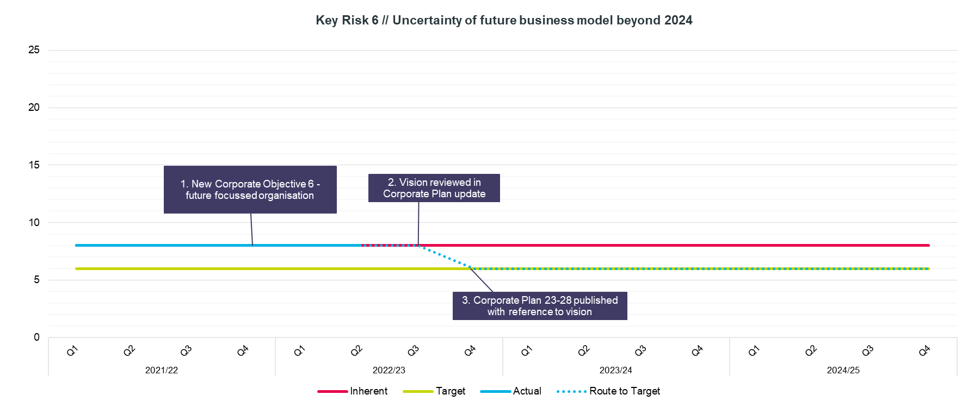

Draft Risk Management Policy 2022
- The draft policy is at Annex 2. One addition and one minor change are proposed:
  - Para. 4.3, addition of: “Heads of Service are responsible for ensuring risk management activity informs business continuity arrangements for their services”.
This responds to recommendation 2 in the March 2022 business continuity planning internal audit report (to better connect risk management and business continuity planning). ERM will provide support and guidance for Heads of Service to enable them to meet this new policy requirement.
  - Para. 4.5, change: “consultancy” removed, “support” substituted.
This better reflects the current ERM service offer.
- The EMT approved timescale for 2022 annual review of the risk management policy is noted in the draft policy. EMT and ARC have reviewed the proposed changes and support their adoption. PCS have reviewed the policy and offered no comment.
Conclusion

- RoS Board to review the KRR update and Risk Management policy at Annexes 1 and 2, and consider the background, topic matter and recommendations in this paper for advice to the Keeper and EMT.

Head of Enterprise Risk Management
29 November 2022

Annex 1
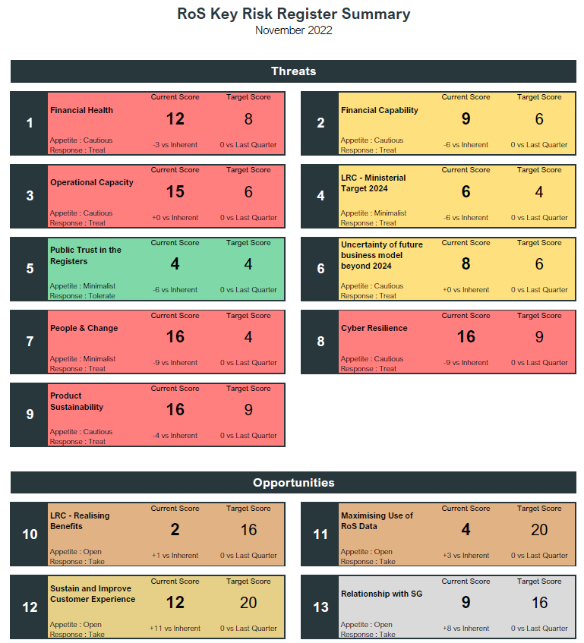

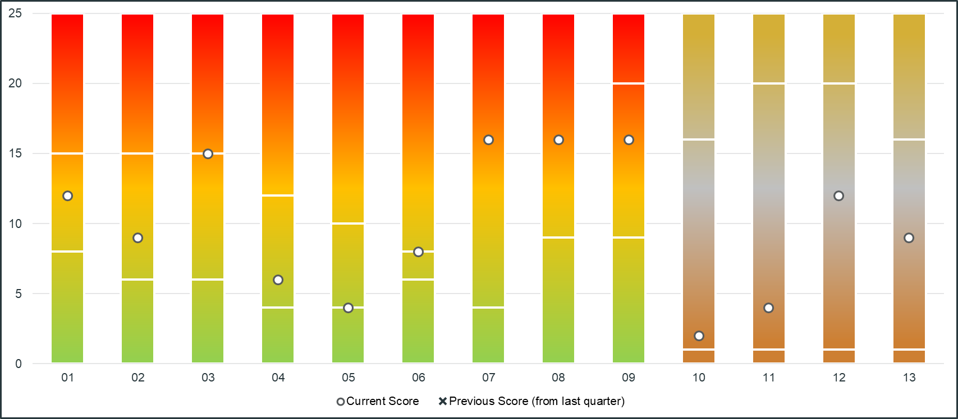
Annex 2
Risk Management Policy
Author | Head of Enterprise Risk Management
Reviewed | Head of Risk & Information Governance
Cleared | Corporate Services Director
Approval | EMT | Approval Date | 15/12/22
Policy Version | 1.0
Review Responsibility | RoS Board  ARC  PCS  EMT | Review Date | 13/12/22  08/11/22  14/10/22  29/09/22
Suitable for Publication | Y
Contact: | rossecretariat@ros.gov.uk

1 Purpose and Scope
  - The RoS Board and Executive Management Team (EMT) recognise that RoS will face a variety of risks in delivering its objectives.
  - This policy sets out RoS commitment to responding to the identified threats to achieving our objectives and opportunities for increasing likelihood of success.
  - In doing so, the Keeper, RoS Board and the EMT are also committed to supporting the benefits from deploying and resourcing an integrated enterprise risk management (ERM) framework for strategic, change and operational risks, set in the context of the Corporate Plan and risk appetite agreed by RoS Board and EMT.
  - This policy applies to all enterprise activities in RoS including all people, processes, premises, technology, information and supply chain activities.

2 Guiding Principles
2.1 The principles of this policy are to:
- ensure it is proportionate and fit for purpose in line with the Scottish Public Finance Manual (SPFM) risk management and internal control guidance
- ensure it is aligned to the context set by the Corporate Plan
- ensure it has a comprehensive scope covering all of our activities
- ensure it is embedded across the organisation
- ensure it is dynamic to respond to change
3 The Policy
3.1 RoS objectives for enterprise risk management (ERM) are to:
- provide appropriate risk information to support decision making at all levels
- assist in achieving economic, efficient and effective processes to achieve the best outcomes, reduced uncertainty and a supportive risk culture
- achieve compliance with our mandatory obligations
- provide assurance that our internal control activities and risk management practice comply with our risk management principles
- Roles and responsibilities
  - The EMT is responsible for the content of this policy, its approval and review, which includes the RoS Board and its Audit & Risk Committee (ARC). They are responsible for ensuring its implementation in practice and for monitoring this over time. They are also responsible for ensuring that appropriate procedures, guidelines or standards as are required to support this are maintained and ownership for these assigned appropriately.
  - The RoS Accountable Officer has responsibility for delivery of the enterprise wide implementation of the policy, principles and objectives. The Accountable Officer also approves the governance statement within the RoS Annual Report and Accounts (ARA). The ARA governance statement outlines and evaluates the governance, risk management and internal control arrangements in place during the preceding year. The ARC supports and advises the Accountable Officer in monitoring the corporate governance, risk, value for money and control systems in RoS.
  - All Heads of Service are responsible for leading risk management for their services and providing annual certificates of assurance and assurance opinions to the Accountable Officer for the ARA governance statement. Heads of Service are responsible for ensuring risk management activity informs business continuity arrangements for their services.
  - All RoS colleagues have a responsibility to be aware of risk, and to support and participate in risk management activities led by Heads of Service.
  - The RoS ERM service is responsible for the delivery of the integrated ERM framework, including enterprise-wide support, training and awareness, on behalf of the Accountable Officer.

5 Approval and review
5.1 This policy will be reviewed annually, unless earlier review is appropriate, by the ARC and RoS Board and approved by EMT.

